**Name : . Mauricio S. Perez .**

**CSC 18C Quiz #4 (25 pts) – May 17th, 2016**

All answers must be of your own work. Type out your answers and submit your quiz through Blackboard for Quiz #2 as either a MS Word document or PDF file (Mac users using Pages, make sure to Export to MS Word).

1. **True / False**: You can create different binary search trees from the same data. ( 5 points )

True: You can make different traversals*: inorder , pre-order, post-order*.

1. Draw the binary search tree from the following input. (10 points)  
    4, 10, 12, 54, 19, 27, 7, 2

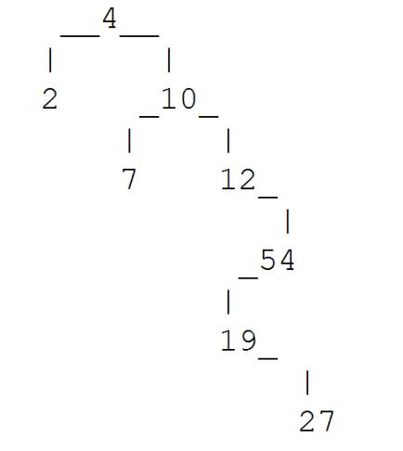

1. 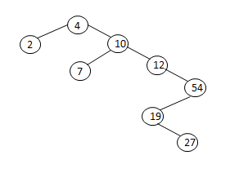Given the following binary search tree, draw the tree after adding 3. (10 points)

Before 3:

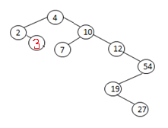

After 3: